Module 1 – Overview of IT Industry
What is a Program?
A program is a set of instructions that tells a computer what to do. It is written by a programmer using a programming language such as Python, Java, or C++.
These instructions guide the computer step by step to perform specific tasks — for example, adding numbers, displaying messages, or controlling a device.
When a program runs, the computer’s processor follows each instruction in order, carrying out calculations, moving data, or showing results on the screen.
In simple words, a program is how humans communicate with computers to make them perform useful actions.
LAB EXERCISE: Write a simple "Hello World" program in two different programming languages of your choice. Compare the structure and syntax.
#include<stdio.h>
//to print hello world
/*

*/
main(){
printf("hello world");

}
THEORY EXERCISE: Explain in your own words what a program is and how it functions.
A program is a set of instructions given to a computer to make it perform a specific task.
It functions by:
- Accepting input
- Processing the instructions step by step
- Producing output
In simple words:
A program tells the computer what to do, and the computer follows those steps exactly.

What is Programming?
Programming is the process of giving instructions to a computer so it can perform specific tasks. These instructions are written in a programming language like C, Python, or Java.
In simple words:
Programming is teaching a computer what to do by writing step-by-step commands.
Why we do programming:
- To solve problems
- To create software and apps
- To automate tasks
- To make computers work efficiently
So, programming is basically telling the computer how to work using clear, logical instructions.

THEORY EXERCISE: What are the key steps involved in the programming process?
The key steps involved in the programming process are:
- Problem Definition
Understand what needs to be done.
- Planning / Algorithm Design
Write the steps or logic to solve the problem.
- Coding
Convert the algorithm into a programming language.
- Compiling / Executing
Run the program to check if it works.
- Testing & Debugging
Find and fix errors or mistakes.
- Documentation
Write details about how the program works.
- Maintenance
Update and improve the program when needed.
These steps help ensure the program is correct, efficient, and easy to maintain.

Types of Programming Languages
Here are the main types of programming languages:
1. Low-Level Languages
These are close to machine language.
- Machine Language (binary: 0s and 1s)
- Assembly Language (uses short codes like MOV, ADD)
2. High-Level Languages
These are easy to read and write.
- Examples: C, C++, Java, Python, JavaScript
3. Procedural Languages
Follow step-by-step instructions.
- Examples: C, Pascal, Fortran
4. Object-Oriented Languages (OOP)
Based on objects and classes.
- Examples: Java, C++, Python, C#
5. Scripting Languages
Used for automation and quick tasks.
- Examples: Python, JavaScript, PHP, Ruby
6. Functional Languages
Focus on mathematical functions.
- Examples: Haskell, Lisp, Scala
7. Markup Languages (not exactly programming but used in development)
- Examples: HTML, XML
If you want, I can also explain each type in simple words or give examples.

THEORY EXERCISE: What are the main differences between high-level and low-level programming languages?
Here are the main differences between high-level and low-level programming languages:
1. Level of Abstraction
- High-Level Languages:
Closer to human language; easy to understand.
- Low-Level Languages:
Closer to machine language; harder to understand.
2. Ease of Use
- High-Level: Easy to write, read, and debug.
- Low-Level: Difficult to write and understand.
3. Machine Dependency
- High-Level: Mostly machine-independent (portable).
- Low-Level: Machine-dependent (specific to hardware).
4. Execution Speed
- High-Level: Slower because they need interpretation or compilation.
- Low-Level: Faster because they interact directly with hardware.
5. Examples
- High-Level: C, C++, Java, Python.
- Low-Level: Machine language (0s and 1s), Assembly language.
In short:
High-level languages are easier for humans, while low-level languages are easier for computers.

World Wide Web & How Internet Works
LAB EXERCISE: Research and create a diagram of how data is transmitted from a client to a server over the internet.
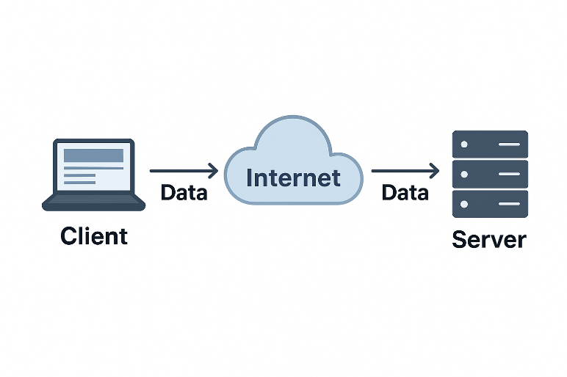

THEORY EXERCISE: Describe the roles of the client and server in web communication.
Network Layers on Client and Server

LAB EXERCISE: Design a simple HTTP client-server communication in any language.
THEORY EXERCISE: Explain the function of the TCP/IP model and its layers.
Client and Servers
THEORY EXERCISE: Explain Client Server Communication
Types of Internet Connections
LAB EXERCISE: Research different types of internet connections (e.g., broadband, fiber, satellite) and list their pros and cons.
THEORY EXERCISE: How does broadband differ from fiber-optic internet?
Protocols
LAB EXERCISE: Simulate HTTP and FTP requests using command line tools (e.g., curl).
THEORY EXERCISE: What are the differences between HTTP and HTTPS protocols?
Application Security
LAB EXERCISE: Identify and explain three common application security vulnerabilities. Suggest possible solutions.
THEORY EXERCISE: What is the role of encryption in securing applications?
Software Applications and Its Types
LAB EXERCISE: Identify and classify 5 applications you use daily as either system software or application software.
THEORY EXERCISE: What is the difference between system software and application software?
Software Architecture
LAB EXERCISE: Design a basic three-tier software architecture diagram for a web application.
THEORY EXERCISE: What is the significance of modularity in software architecture?
Layers in Software Architecture
LAB EXERCISE: Create a case study on the functionality of the presentation, business logic, and data access layers of a given software system.
THEORY EXERCISE: Why are layers important in software architecture?
Software Environments
LAB EXERCISE: Explore different types of software environments (development, testing, production). Set up a basic environment in a virtual machine.
THEORY EXERCISE: Explain the importance of a development environment in software production.
Source Code
LAB EXERCISE: Write and upload your first source code file to Github.
THEORY EXERCISE: What is the difference between source code and machine code?
Github and Introductions
LAB EXERCISE: Create a Github repository and document how to commit and push code changes.
THEORY EXERCISE: Why is version control important in software development?
Student Account in Github
LAB EXERCISE: Create a student account on Github and collaborate on a small project with a classmate.
THEORY EXERCISE: What are the benefits of using Github for students?
Types of Software
LAB EXERCISE: Create a list of software you use regularly and classify them into the following categories: system, application, and utility software.
THEORY EXERCISE: What are the differences between open-source and proprietary software?
GIT and GITHUB Training
LAB EXERCISE: Follow a GIT tutorial to practice cloning, branching, and merging repositories.
THEORY EXERCISE: How does GIT improve collaboration in a software development team?
Application Software
LAB EXERCISE: Write a report on the various types of application software and how they improve productivity.
THEORY EXERCISE: What is the role of application software in businesses?
Software Development Process
LAB EXERCISE: Create a flowchart representing the Software Development Life Cycle (SDLC).
THEORY EXERCISE: What are the main stages of the software development process?
Software Requirement
LAB EXERCISE: Write a requirement specification for a simple library management system.
THEORY EXERCISE: Why is the requirement analysis phase critical in software development?
Software Analysis
LAB EXERCISE: Perform a functional analysis for an online shopping system.
THEORY EXERCISE: What is the role of software analysis in the development process?
System Design
LAB EXERCISE: Design a basic system architecture for a food delivery app.
THEORY EXERCISE: What are the key elements of system design?
Software Testing
LAB EXERCISE: Develop test cases for a simple calculator program.
THEORY EXERCISE: Why is software testing important?
Maintenance
LAB EXERCISE: Document a real-world case where a software application required critical maintenance.
THEORY EXERCISE: What types of software maintenance are there?
Development
THEORY EXERCISE: What are the key differences between web and desktop applications?
27. Web Application

THEORY EXERCISE: What are the advantages of using web applications over desktop applications?
28. Designing

THEORY EXERCISE: What role does UI/UX design play in application development?
29. Mobile Application

THEORY EXERCISE: What are the differences between native and hybrid mobile apps?

30. DFD (Data Flow Diagram)

LAB EXERCISE: Create a DFD for a hospital management system.
THEORY EXERCISE: What is the significance of DFDs in system analysis?
31. Desktop Application

LAB EXERCISE: Build a simple desktop calculator application using a GUI library.
THEORY EXERCISE: What are the pros and cons of desktop applications compared to web applications?
32. Flow Chart

LAB EXERCISE: Draw a flowchart representing the logic of a basic online registration system.
THEORY EXERCISE: How do flowcharts help in programming and system design?

